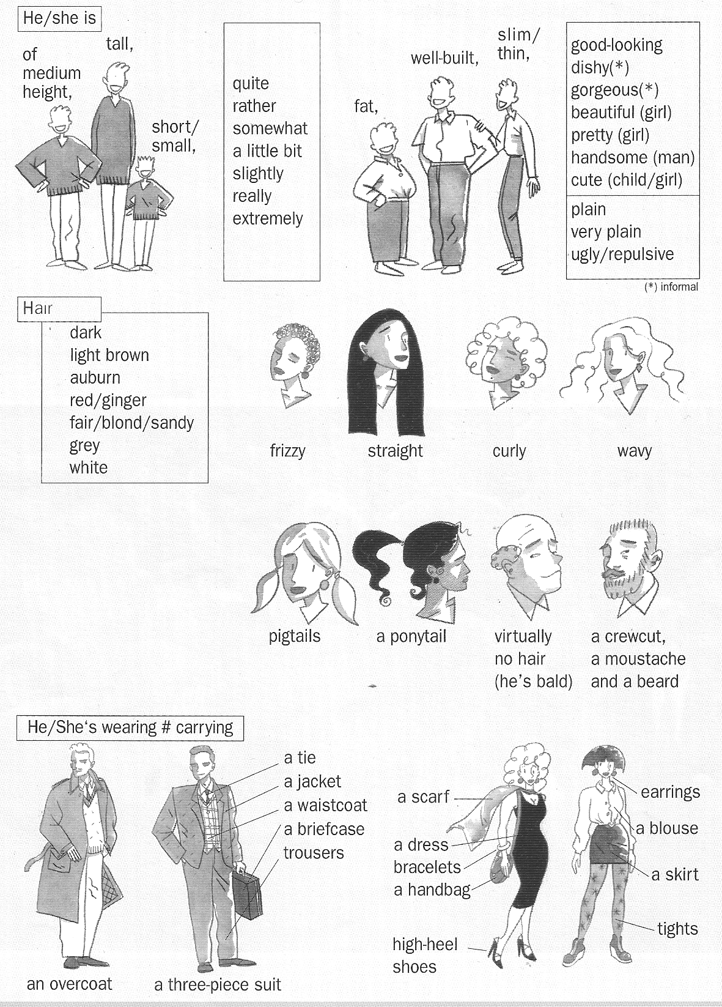
DESCRIBING PEOPLE

